Displaying categorical data – bar charts and pie charts
Case 1. Count or percent is given for each category.
Highlight the table, names and counts of each category, then go to the “Insert” tab and find the “Charts” section. Press on a Bar Chart or a Pie Chart. You can find them in “Recommended charts” as well.

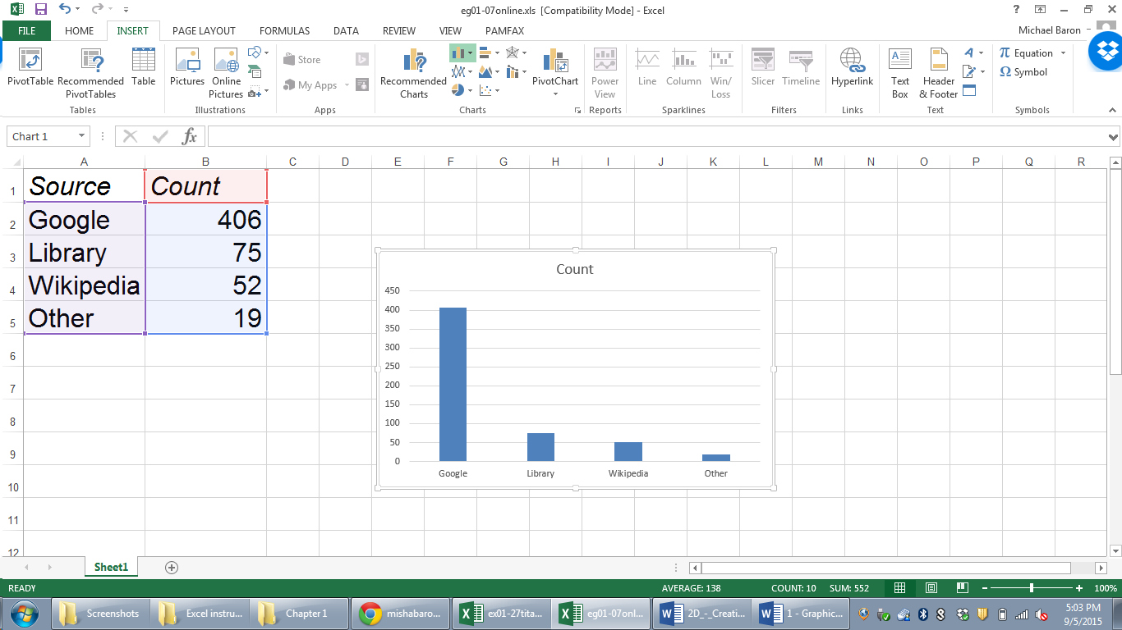

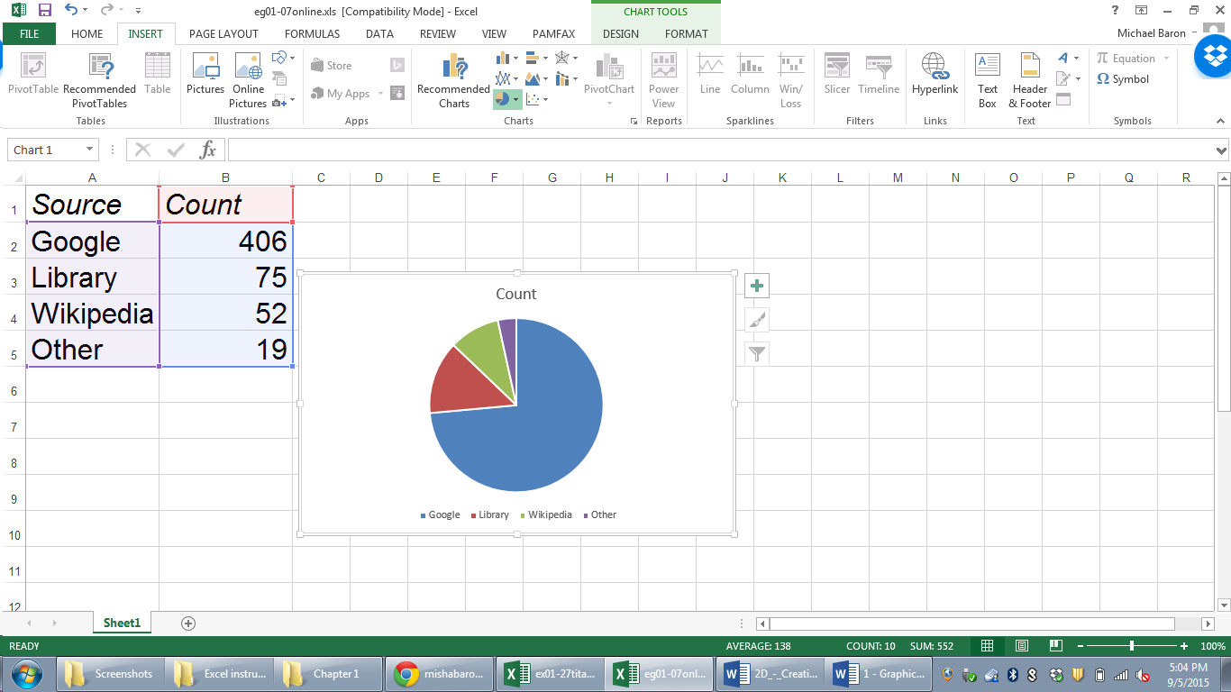

Case 2. Only raw data are given.
Calculate the counts using Excel function =countif(range,criteria). It counts how many values in the chosen range meet the specified criteria.
For the range, highlight the column with the raw data. For the criterion, write the code of the corresponding category.
In the following example of Titanic passengers data, here is how you can draw pie charts of the passengers’ class, gender, and survival.
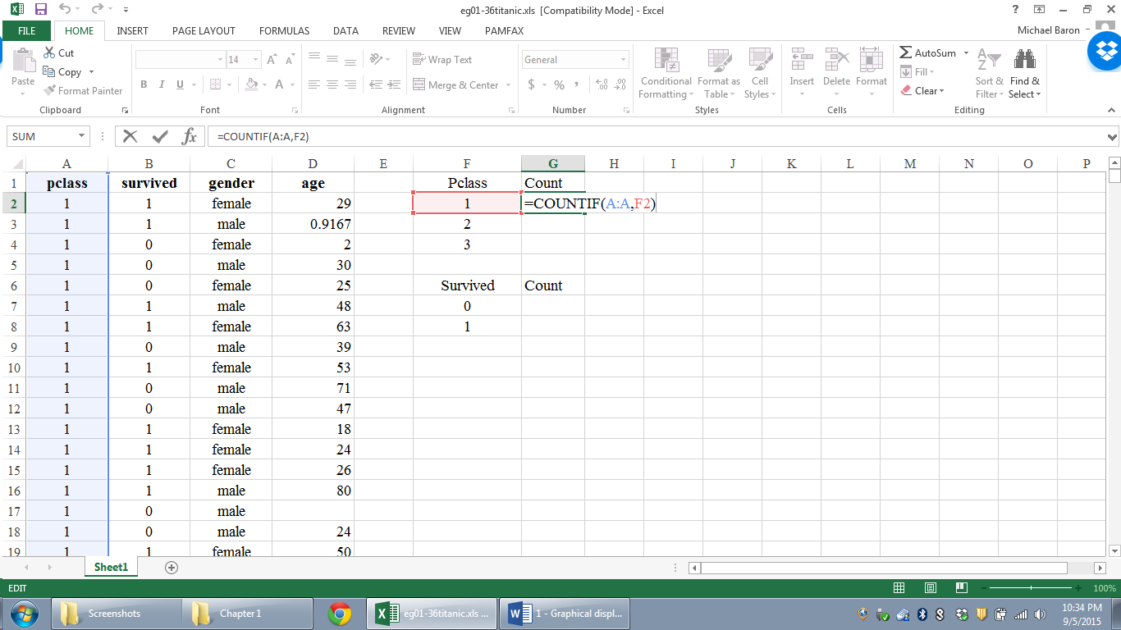
To get a count of passengers in the 1st class, you can write 1 as a criterion =countif(A:A,1). Instead, as you see, I wrote “F2”. Excel knows to take the value in the F2 cell, which is 1.
This way, I can extend my formula to the 2nd and the 3rd classes without rewriting the formula. Put the cursor into the left-bottom corner of the cell until the little cross becomes black and drag it to the other cells.
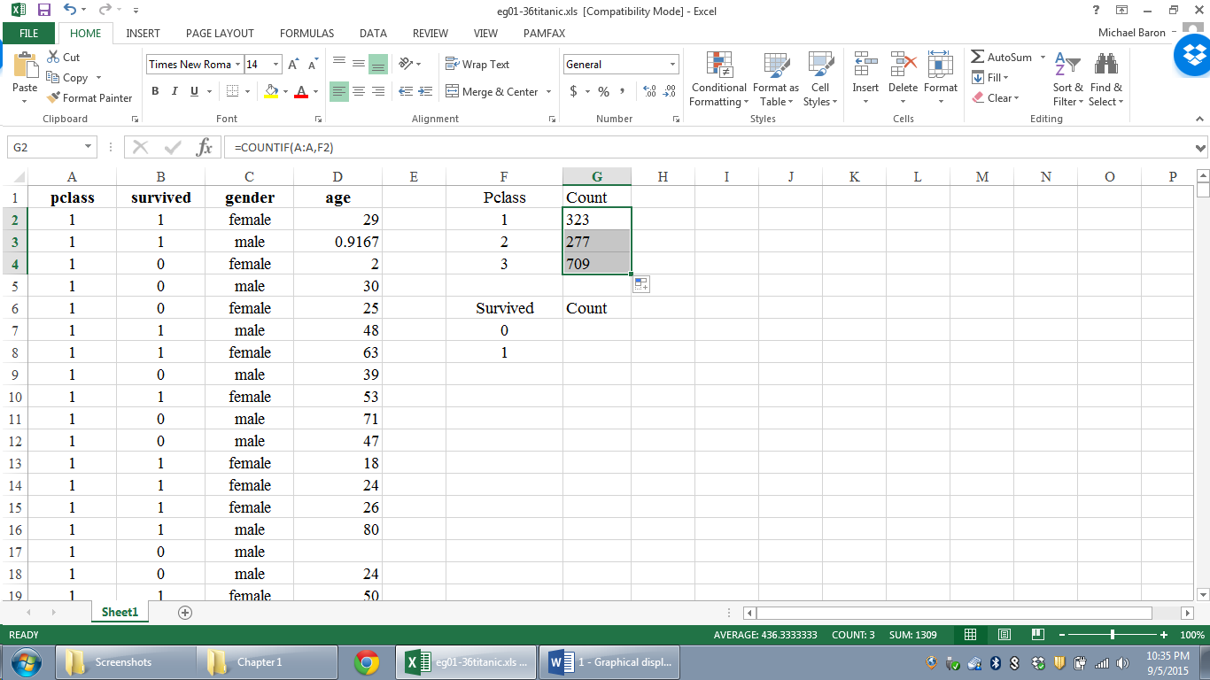

After this prep, the data are ready for graphical displays. For each variable, go
Insert -> Charts -> pie chart or bar chart.
When you write criteria in =countif for the string variable “gender” (values are not numbers but strings), put values “female” and “male” into double quotes:
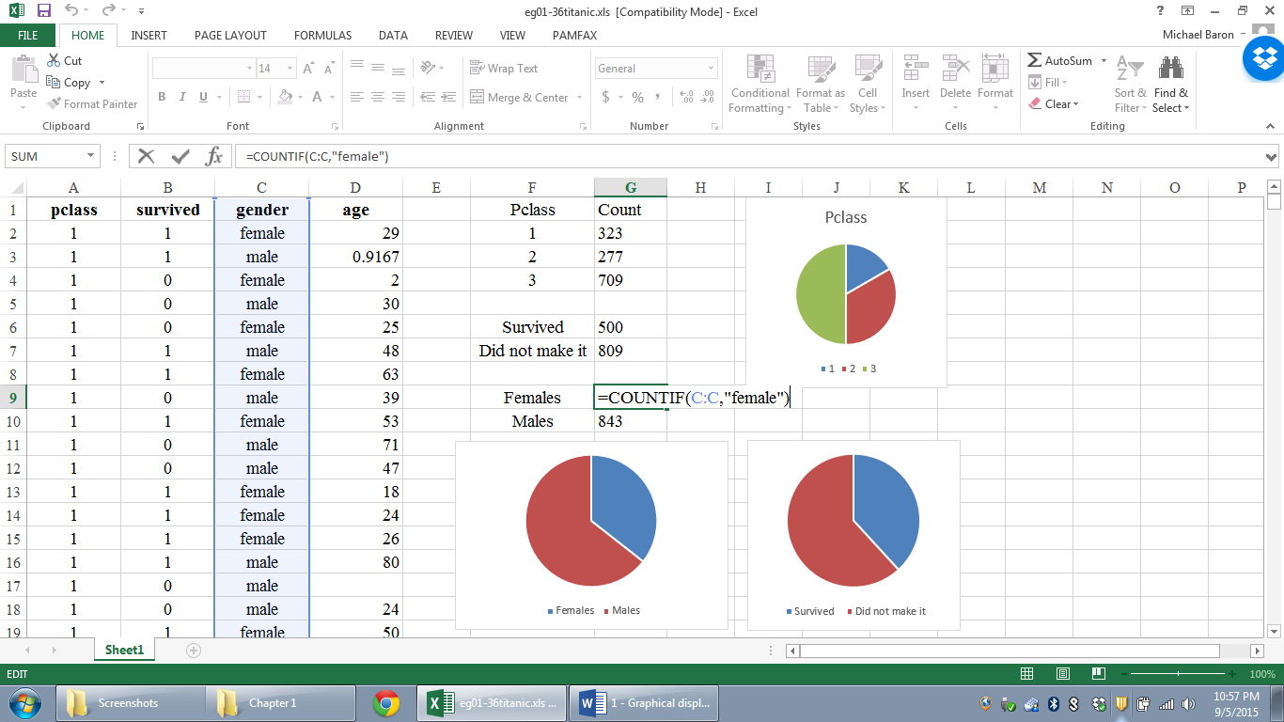

Displaying a relation between two variables
To see how the chance of survival on the Titanic depended on the passenger’s class, we can use side-by-side bar charts.
First, we need to create a table of cross-counts. One way to do this is to sort all the data by survival. Go to the DATA tab, click Sort, and a box will appear. Choose sorting by “survived” and order from “smallest to largest” (“largest to smallest” is fine too). Click OK.
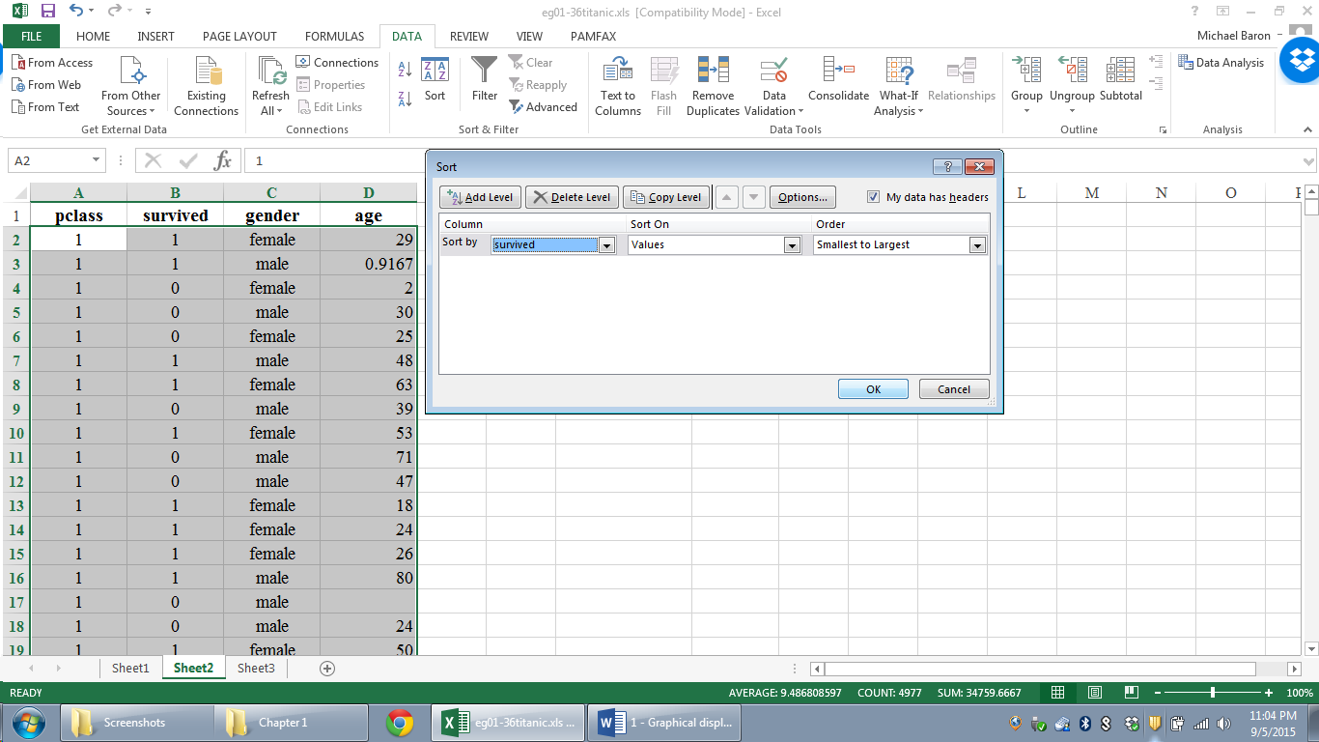

As a result, all perished passengers will be listed first, followed by the survivors. Then we can apply =countif to the victims and survivors separately, as on this picture.
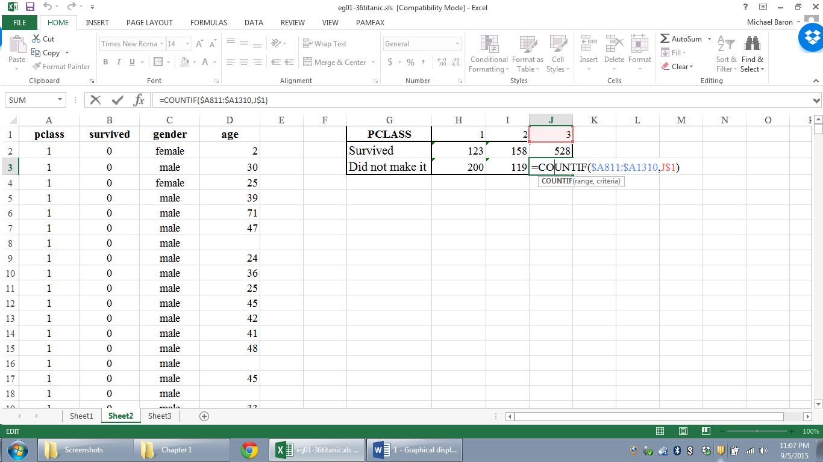

Insert -> Charts -> Bar chart produces this.
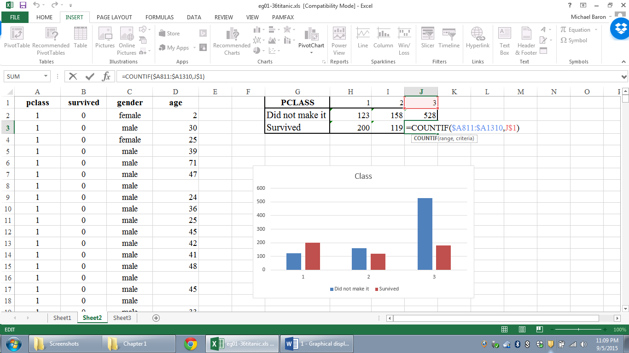
These side-by-side bar charts show that the proportion of survivors was much smaller in the 3rd class… as we saw in the movie Titanic.

3. Displaying numerical data with histograms
Find the range of possible values of our data. If it is not known in advance, you can use =min and =max functions.
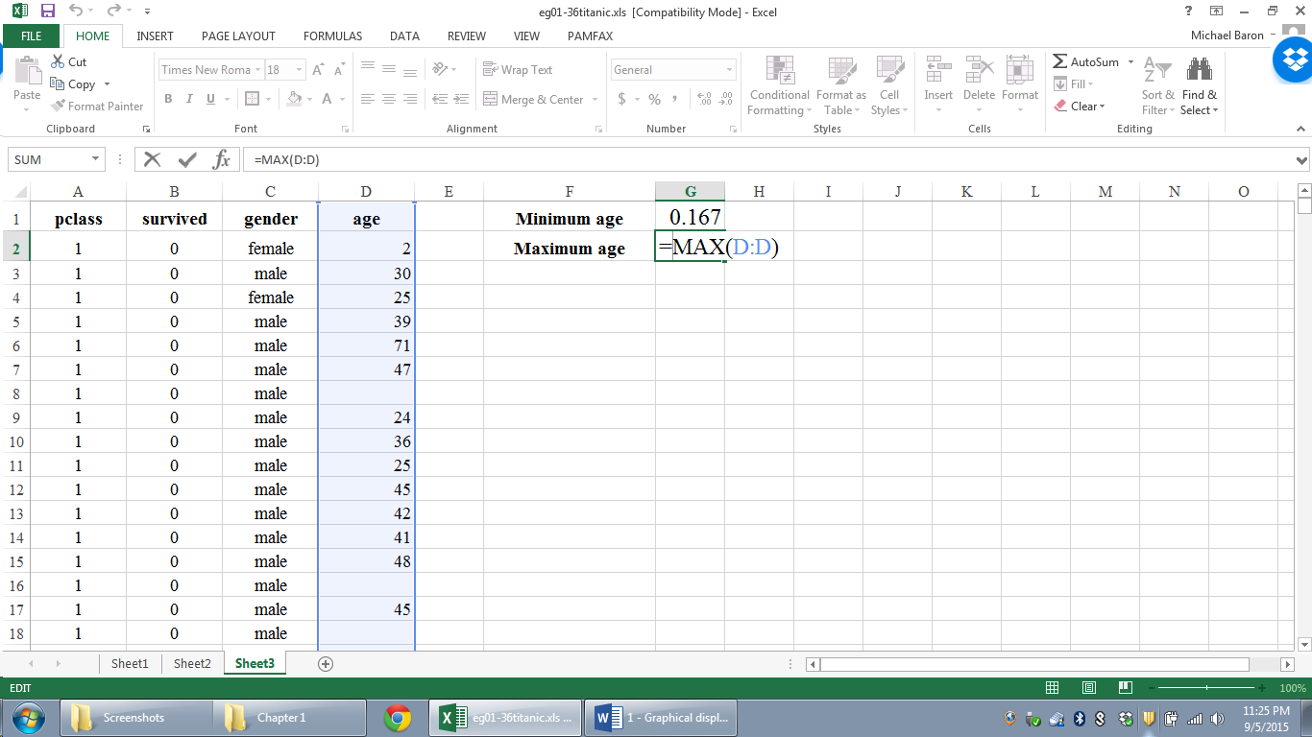
The bins can then be written manually between these min and max. Normally, arrange between 7 and 15 bins of equal width.
To produce a histogram, use the Data Analysis ToolPak. Go to the DATA tab, find the Toolpak on the far right, and in the appearing box, choose “Histogram”.
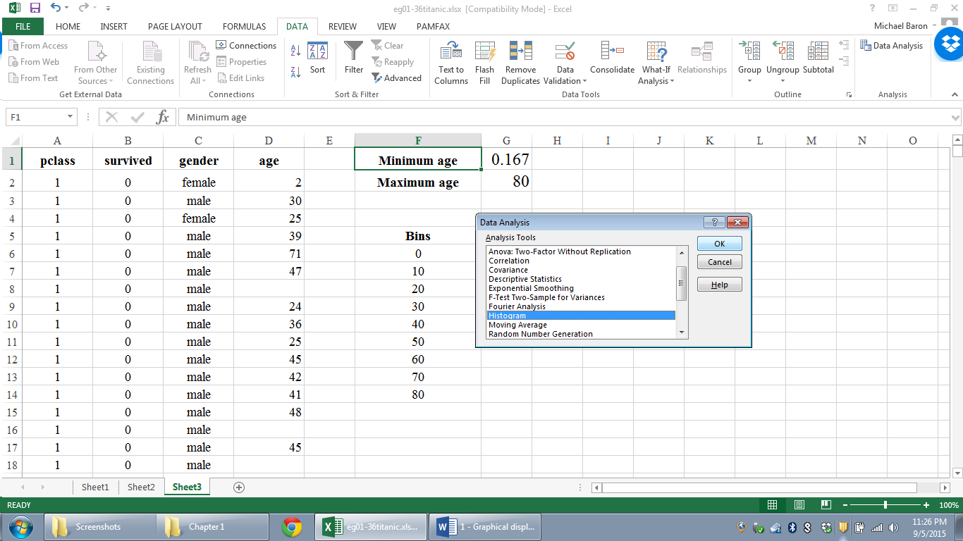
In the next box, write or just highlight the input column and the bins that you just wrote. For output range, choose the place where you want the histogram to be, and check the box “Chart Output”. Also, check “Labels” to claim that we have column headings in the 1st row.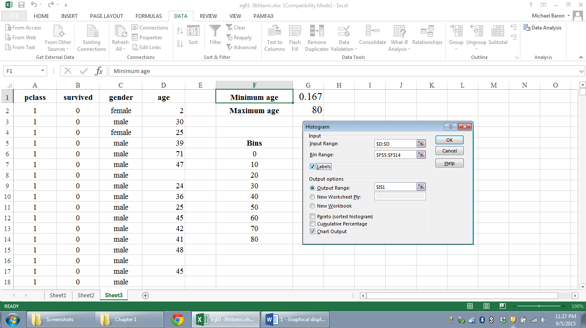
The resulting histogram shows a unimodal and almost symmetric distribution of passenger ages on the Titanic.
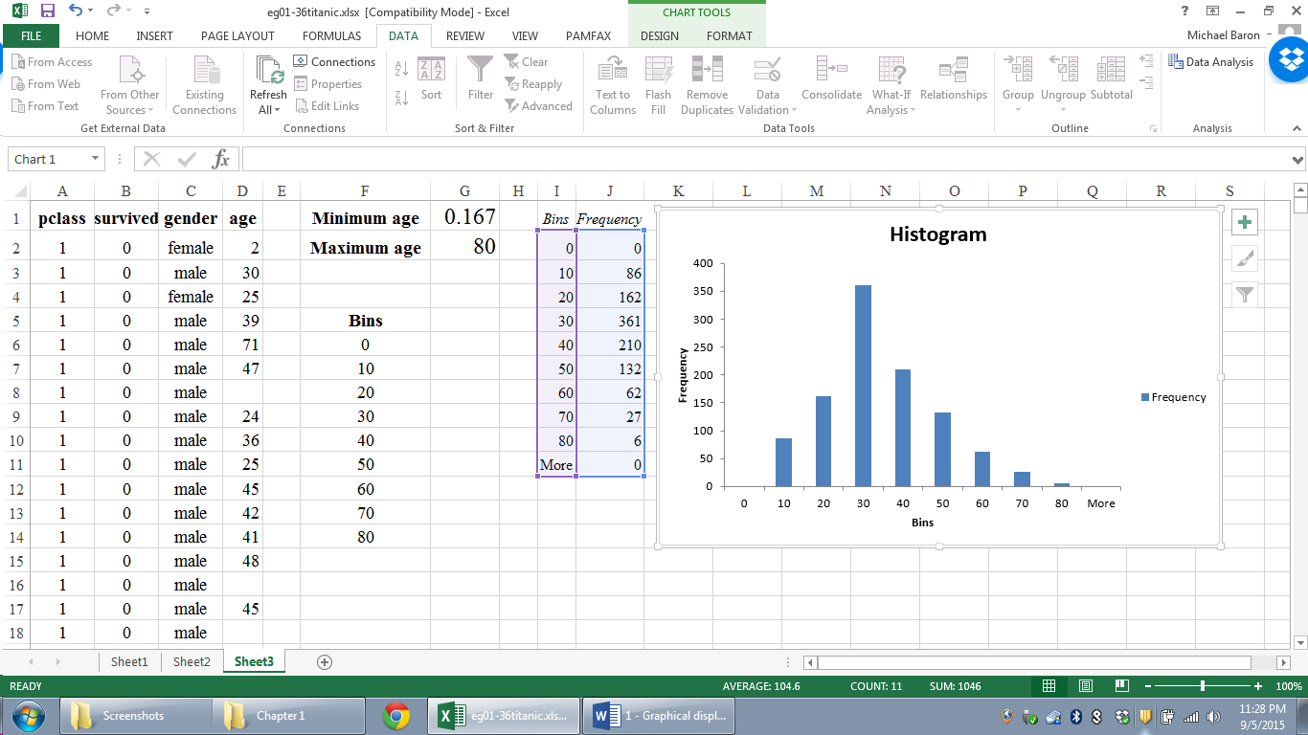
Scatterplots and Time Plots
Insert -> Charts -> Choose a scatteplot that you like.
The scatterplot below shows that on the average, the more a newspaper spends on advertising the larger sales it gets.
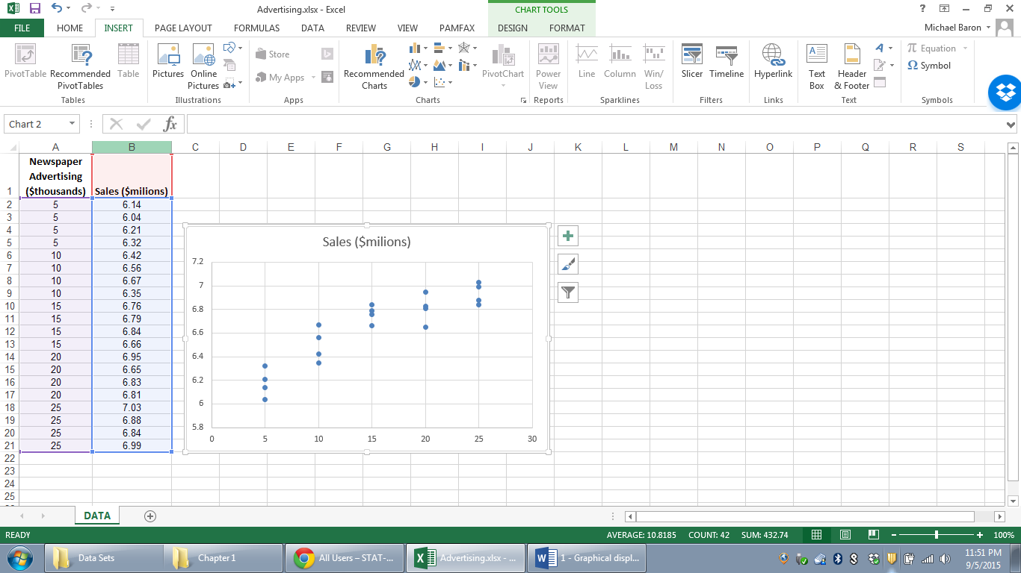
Time series plots are done similarly, with X-variable being time.

